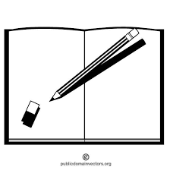
Save the Sentence!
Can you add commas to these sentences so that the reader does not
have to read all these ‘ands’! Re-write the sentences in your book

