Watch the story of ‘The Tiger who came to tea’ using the link below.  https://www.youtube.com/watch?v=z9IPZR16fdY  The author uses the words ‘big’, ‘furry’ and ‘stripy’ to describe the tiger. Can you think of any more adjectives? | Look at the tiger’s stripes. Find out what camouflage is and how it helps tigers.  Can you find out how other animals use camouflage to help them? | Can you remember what the Tiger ate and drank at Sophie’s house?  If the tiger came to your house, what would he find to eat and drink in the cupboards? Make a list.
Imagine if a different animal came to tea.  How would they behave?  What might they eat?  Write a story about this. | Create a food label for a tin of ‘tiger food’ that Sophie and her Mummy could have got at the shops.  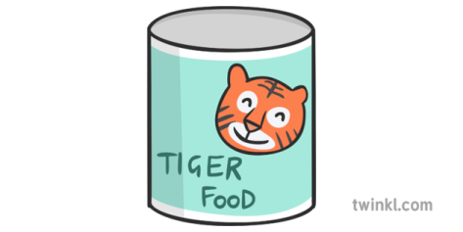 | Draw 2 pictures of the inside of the fridge. One before the tiger ate all the food and one after!
Imagine a tiger came to live at your house! Use a variety of books and the internet to find out what tigers hunt and eat, how they behave, play and move.  Describe how you would take care of their tiger. Make their own ‘Tiger Care’ booklets, describing the most important things to remember when looking after a tiger! | Have you ever wanted your favourite animal to ring the doorbell?  Is there a person you’ve always wanted to meet?  Draw a favourite teatime guest and write a sentence to explain why you would like them to come to tea. | How many types of ‘Big Cat’ can you think of?  Choose one and create a poster with labels to show where it lives, what it eats and what it looks like.  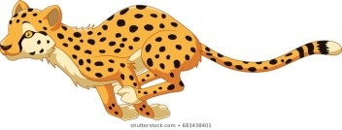  Challenge: You could create a fact file instead of a poster!

