How to access Get Epic Reading
Step 1 – Type Get epic into Google Chrome and click Log In
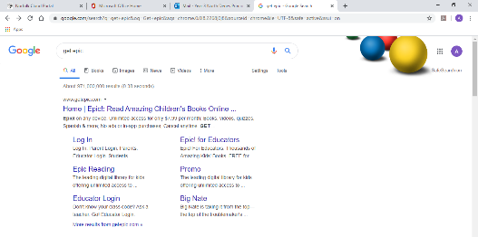

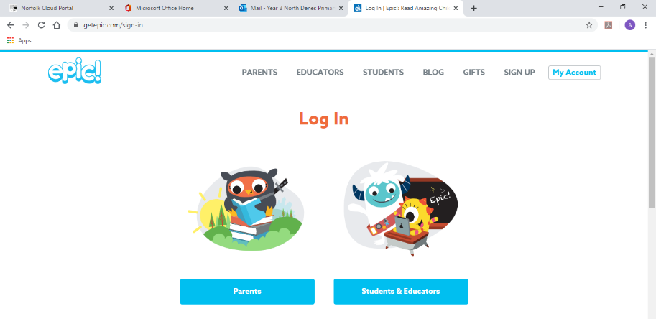
Click Students and Educators

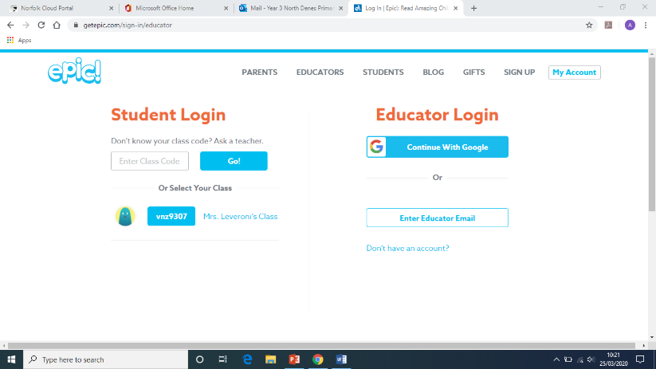
Click Mrs Leveroni’s class

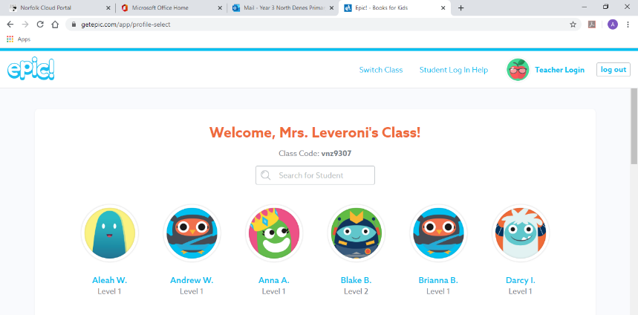
Find your name on the class list and you should be able to choose books

Hope this helps

