Choose 5 items from your kitchen cupboards and put them in weight order from lightest to heaviest using the labels to guide you. | On your daily walk see if you can read the different house numbers. What’s the highest number you can spot? | Do some baking and help measure out the ingredients. Send us your photos!
How many pairs of shoes do you have in your house? Can you count them in 2s?  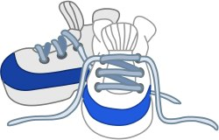 | Paint a symmetrical picture by folding a piece of paper in half and only painting one side. Then fold it over to print the pattern so it’s on the other side. Perhaps a rainbow or butterfly. | Go on a shape hunt around the house. Can you find a square, rectangle, triangle and circle?  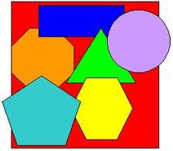  Maybe you can find some 3D shapes too!
Create a tally chart of your family’s favourite animal or another category of your choice. Ask grandparents, aunties, uncles and cousins too. Which one was the winner? | Using a tube of Smarties:  First estimate how many you think are in the tube and then count them.  How many are there of each colour?  Which colour is there most of?  Which colour is there least of?  Compare with another tube of Smarties. | First predict and then count how many of these you can do in a minute:  Star jumps  Press ups  Squat jumps  Challenge: Can you beat your score?

